**STOCK MARKET PREDICTOR**

Gaurav Sharma

1810350

**ZERO LEVEL DIAGRAM :-**

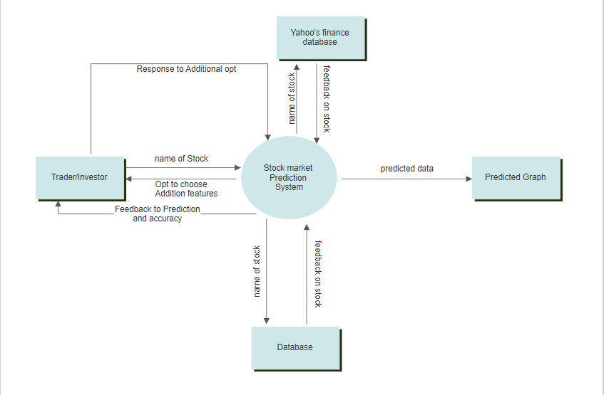

**FIRST LEVEL DIAGRAM :-**

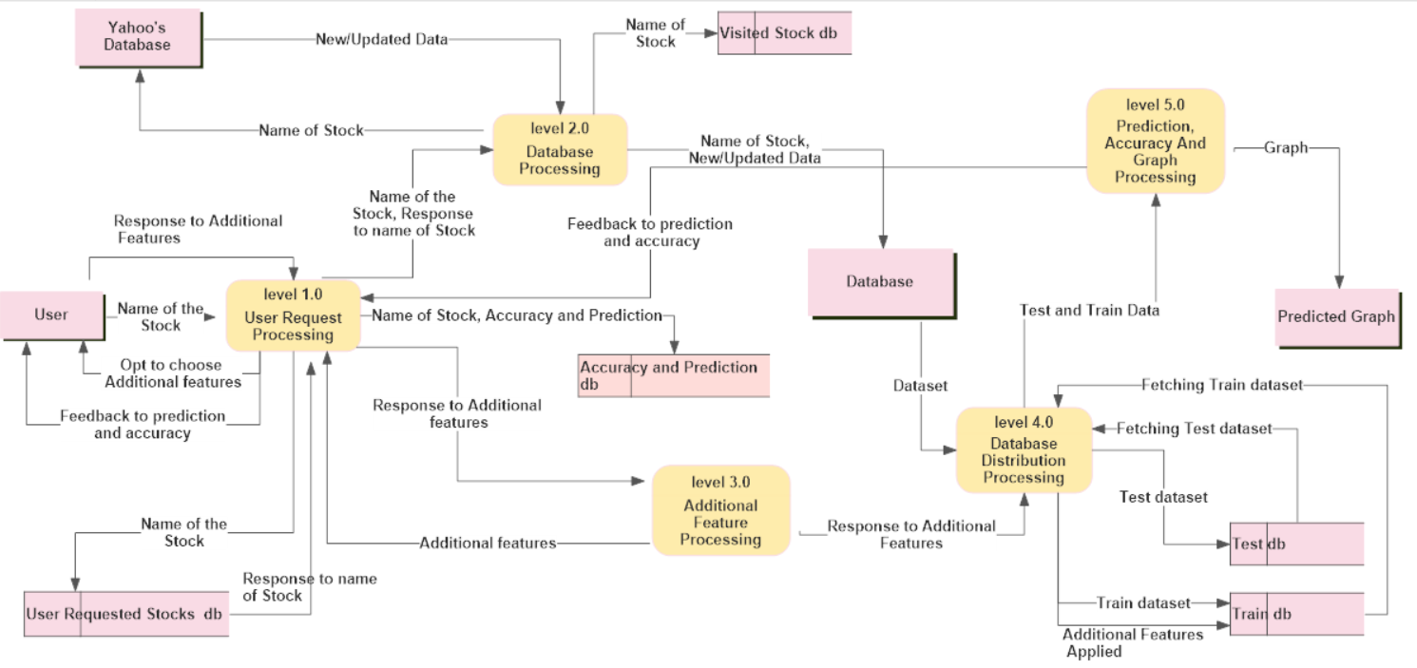

**Level 1.1 Detailed :-**

